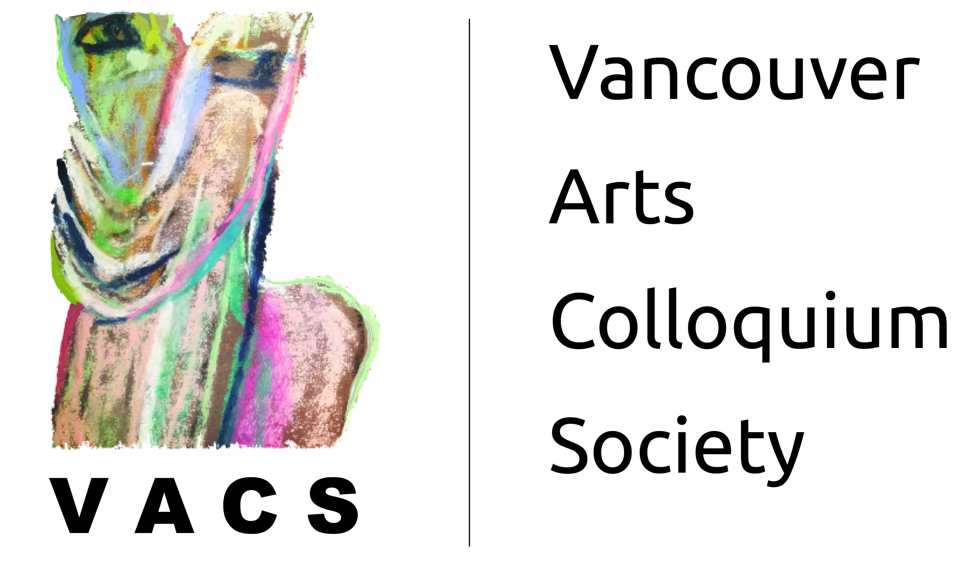**Upcycling Fabrics Workshop**

**Participants & Contact Info**

|  |  |  |
| --- | --- | --- |
| **First Name** | **Last Name** | **E-Mail** |
| Lara | Boleslawsky | lboleslawsky@gmail.com |
| Colleen | Rhodes | meinsdesigns@gmail.com |
| Dawn | Liverd | ko.misti@gmail.com |
|  |  |  |